1️⃣ What is a Transaction in Spring?
A transaction is a group of database operations that must be executed as one logical unit of work.
👉 Either ALL operations succeed
👉 Or ALL operations are rolled back
This follows ACID principles:
- Atomicity – all or nothing
- Consistency – DB remains valid
- Isolation – concurrent transactions don’t interfere
- Durability – committed data is permanent
🧠 Real-world analogy
💳 Online payment
- Debit money
- Credit merchant
- Generate receipt
If any one step fails, the entire operation must rollback.

2️⃣ Why do we need Spring Transaction Management?
❌ Without transaction
Insert Order → SUCCESS
Update Inventory → FAILED ❌
➡ Database becomes inconsistent
✅ With transaction
Insert Order → FAILED
Update Inventory → ROLLBACK
➡ Database remains safe and consistent
Spring makes this easy using declarative transactions.

3️⃣ What is @Transactional Annotation?
📌 Definition
@Transactional is a Spring annotation that:
- Starts a transaction
- Commits if method succeeds
- Rolls back if an exception occurs
You don’t write commit / rollback manually.

4️⃣ Where can we use @Transactional?
Level | Allowed | Recommended
Class | ✅ | Yes
Method | ✅ | ⭐ Best
Interface | ❌ | No
Private method | ❌ | No (Proxy issue)

5️⃣ How @Transactional Works Internally (Important 🔥)
Spring uses AOP (Proxy-based mechanism)
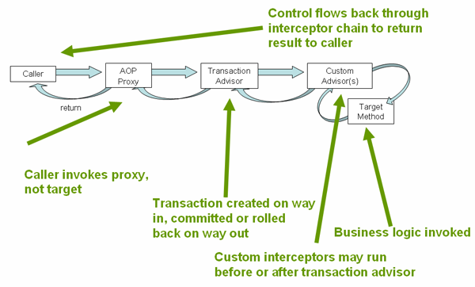
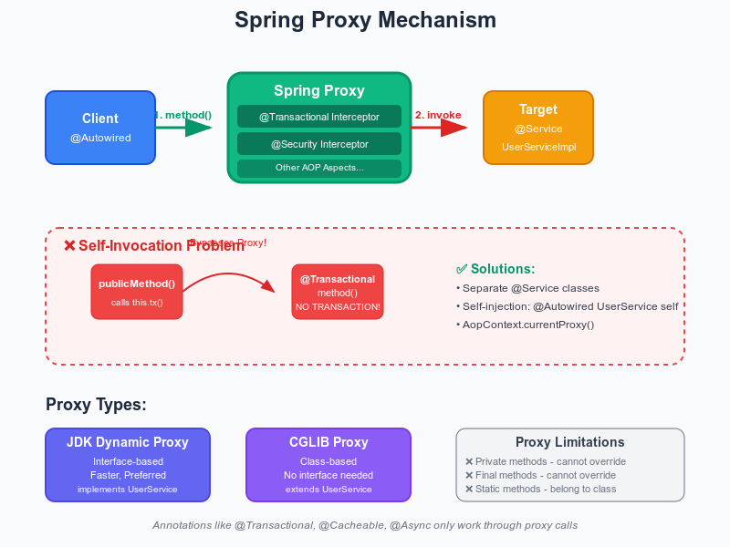
Flow:
- Client calls service method
- Spring proxy intercepts call
- Transaction starts
- Business logic executes
- ✔ Success → COMMIT
❌ Exception → ROLLBACK
⚠️ Important rule
@Transactional does NOT work on self-invocation
this.method(); // Transaction will NOT start

6️⃣ Basic @Transactional Example (Real-Time)
💡 Scenario: Bank Transfer
Service Layer (Best Practice)
@Service
public class BankService {

@Autowired
private AccountRepository accountRepository;

@Transactional
public void transferMoney(int fromId, int toId, double amount) {

accountRepository.debit(fromId, amount);

// Simulating failure
if (amount > 10000) {
throw new RuntimeException("Transfer limit exceeded");
}

accountRepository.credit(toId, amount);
}
}
What happens?
Condition | Result
No exception | ✅ Commit
RuntimeException | ❌ Rollback

7️⃣ Rollback Rules (Very Important for Interviews)
Default Behavior
Exception Type | Rollback
RuntimeException | ✅ Yes
Error | ✅ Yes
Checked Exception | ❌ No
Force rollback for checked exception
@Transactional(rollbackFor = Exception.class)

8️⃣ What is Transaction Propagation?
📌 Definition
Transaction Propagation defines how a transactional method behaves when it is called by another transactional method.
“Should I join an existing transaction or create a new one?”

9️⃣ Transaction Propagation Types (Most Asked Topic 🔥)
1️⃣ REQUIRED (Default ⭐)
@Transactional(propagation = Propagation.REQUIRED)
- Join existing transaction if present
- Create new if none exists
🟢 Most commonly used
📌 Example:
Method A (Tx)
└── Method B → Uses SAME transaction

2️⃣ REQUIRES_NEW
@Transactional(propagation = Propagation.REQUIRES_NEW)
- Suspends existing transaction
- Creates a new independent transaction
📌 Use case:
- Audit logs
- Notifications
- Email logs
Method A (Tx)
├── Method B (NEW Tx)
└── Method A continues

3️⃣ SUPPORTS
@Transactional(propagation = Propagation.SUPPORTS)
- Join transaction if exists
- Else run without transaction
📌 Use case:
- Read-only operations

4️⃣ NOT_SUPPORTED
@Transactional(propagation = Propagation.NOT_SUPPORTED)
- Always runs without transaction
- Suspends existing transaction
📌 Use case:
- Large reports
- Long-running reads

5️⃣ MANDATORY
@Transactional(propagation = Propagation.MANDATORY)
- Must run inside a transaction
- Throws exception if no transaction exists
📌 Use case:
- Strict business rules

6️⃣ NEVER
@Transactional(propagation = Propagation.NEVER)
- Must NOT run inside a transaction
- Throws exception if transaction exists

7️⃣ NESTED
@Transactional(propagation = Propagation.NESTED)
- Runs inside parent transaction
- Uses savepoints
- Rollback only inner part
📌 DB must support savepoints (e.g., MySQL)

🔟 Propagation Summary Table (Quick Revision)
Propagation | Behavior
REQUIRED | Join or create
REQUIRES_NEW | Always new
SUPPORTS | Join or no tx
NOT_SUPPORTED | No tx
MANDATORY | Tx required
NEVER | Tx not allowed
NESTED | Savepoint based

1️⃣1️⃣ Best Practices (Real Project Tips)
✅ Always use @Transactional on Service layer
✅ Avoid using it in Controller
✅ Keep methods public
✅ Prefer REQUIRED unless special case
❌ Don’t catch exceptions silently inside transaction
❌ Avoid long-running transactions

1️⃣2️⃣ Interview One-Line Answers 💡
- What is Spring Transaction?
→ Manages commit & rollback for DB operations automatically.
- What does @Transactional do?
→ Wraps method execution inside a transaction.
- Default propagation?
→ REQUIRED
- Default rollback?
→ RuntimeException only

